E-CAUSE INSTALLATION GUIDE

Software to be installed in the order below:
- Webserver – IIS
- PHP 4.
- MYSQL 4

Step 1 :
Go to My Computer, then Enter Drive C:\
Create a folder called “ecause”
Paste the web application files into that folder

Step 2 :
Create a ECAUSE Virtual Directory using IIS
- 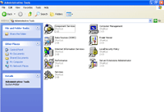Start → Control Panel →Administrative Tools →Internet Information Services
- 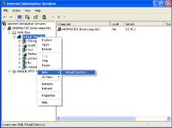Click on the (+) sign beside the Local Computer then Click on the (+) sign beside the folder Web Sites. Right Click on Default Web Site → New →Virtual Directory
- 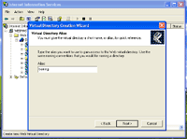Click on NEXT to continue, type in the alias i.e. “ecause”, then choose where it is located on your local drive i.e. c:\ecause, access permissions will be read & run scripts & then click finish. It is imperative to note that what you type under alias can only be access via http://localhost/ecause/

SET DEFAULT HOMEPAGE
- 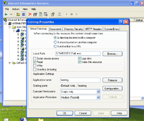Right Click on the Virtual Alias & click properties
- 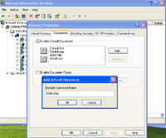Click on Documents then Add, enter the file index.php or index.html or index.htm.

CHECK FOR PHP ENTRY IN IIS
- Right Click on the Virtual Alias & click properties
- 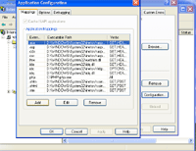Click on Configuration and check the list if PHP is listed. If it is not then , click on ADD , BROWSE locally to where PHP.exe is installed (PHP INTERPRETER) & enter the extension (.php) such that whenever IIS sees the extension the interpreter decodes the information.

Step 3 :
  - Copy & replace PHP folder located in c:\php in the LIVE Laptop with the newly configured system
  - Copy & replace PHP configuration file located in c:\windows\php.ini in the LIVE Laptop with the newly configured system

Step 4 :
Run the Application

http://localhost/ecause/

